

**Group 18** 

**Group Members:**

Alice Wu

David Speers

Deividas Lavrik

Finn Zhan Chen

Mahbub Iftekhar

Mariyana Cholakova

Michal Dauenhauer

# 1 Overview

RoboTour is a robotic tour guide that assists people in environments such as museums or art galleries. The system comprises of an autonomous robotic guide, a companion, purpose built Android application, and a web server mediating the communication between the two. RoboTour can be controlled by up to two Android devices, and the tour may be followed by many more. The app allows users to interact with RoboTour intuitively in multiple languages.

# 2 Installation Instructions

//Seems confusing if we need to clone the repository

//E.g. To set it up you need to clone etc, less ambiguous

//Link on how to use git for the first

## 2.1 Cloning the Repository

To clone the repository, open a new terminal and execute the following command:

$ git clone <https://github.com/mahbubiftekhar/RoboTour.git>

This command will create a new directory called *RoboTour* in your current working directory, and clone the necessary files into it. Instead of using git you may also wish to download the files in a *.zip* archive by following the link in a browser, clicking *Clone or download* then selecting *Download ZIP*.

## 2.2 Installing the Android App

**Prerequisites**: Android SDK version 16 or higher, data connection and 20MB free space on Android device.

You must connect your Android device to the computer with the git repository using a USB cable. Once connected ensure *Device file manager (MTP)* is selected . To install the app on an Android device, installation from unknown sources must be enabled. This feature is turned off by default on stock Android, and can be turned on by following these steps:

*Device Settings* -> *Advanced Settings* -> *Security* -> *Enable Unknown Sources*

Open the git sub-folder *APP APK*, and copy RoboTour.apk file to your Android device. Open the file browser on your Android device, locate the RoboTour.apk, and click on the .apk file. Follow shown steps by the Android package installer which will take you through the permissions required and installation of the app, once finished the app will be installed and can be opened from your app drawer as normal.

# 3 Structure Information

## 3.1 Robot’s Construction and Components

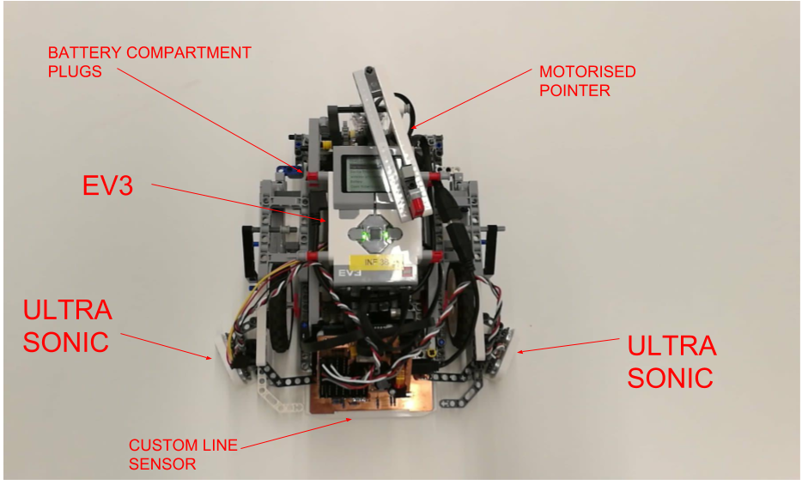

**Fig 1**: Labelled Top View of RoboTour

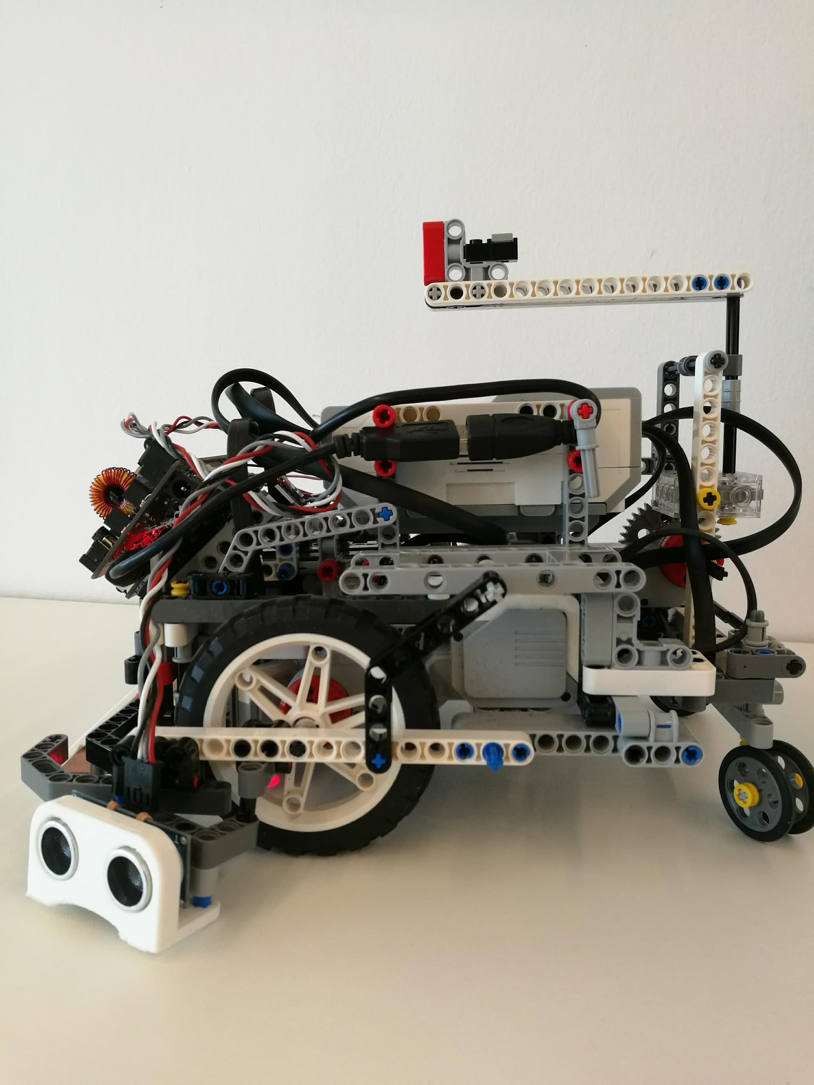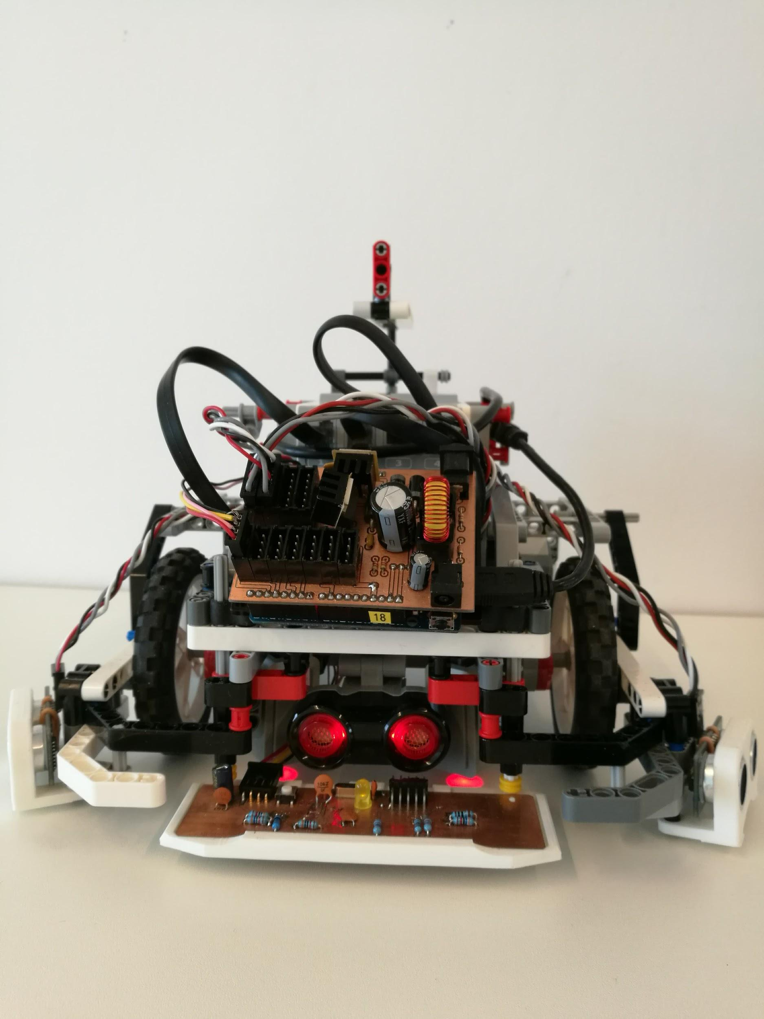

**Fig 2**: Side view of RoboTour **Fig 3**: Back view of RoboTour **Fig 4**: Front view of RobotTour

1x EV3

1x LEGO Ultrasonic sensor

2x LEGO colour sensor

2x HC-SR04 Ultrasonic sensor

1x Custom Line sensor

1x Sensor hub

RoboTour can navigate around using two independently powered wheels, which allows it to move forwards, backwards, and turn. The rear free-moving wheels stabilise the robot and support its weight.

Ultrasonic sensors on the front and sides of the robot allow RoboTour to safely avoid obstacles during its operation. There are also two LE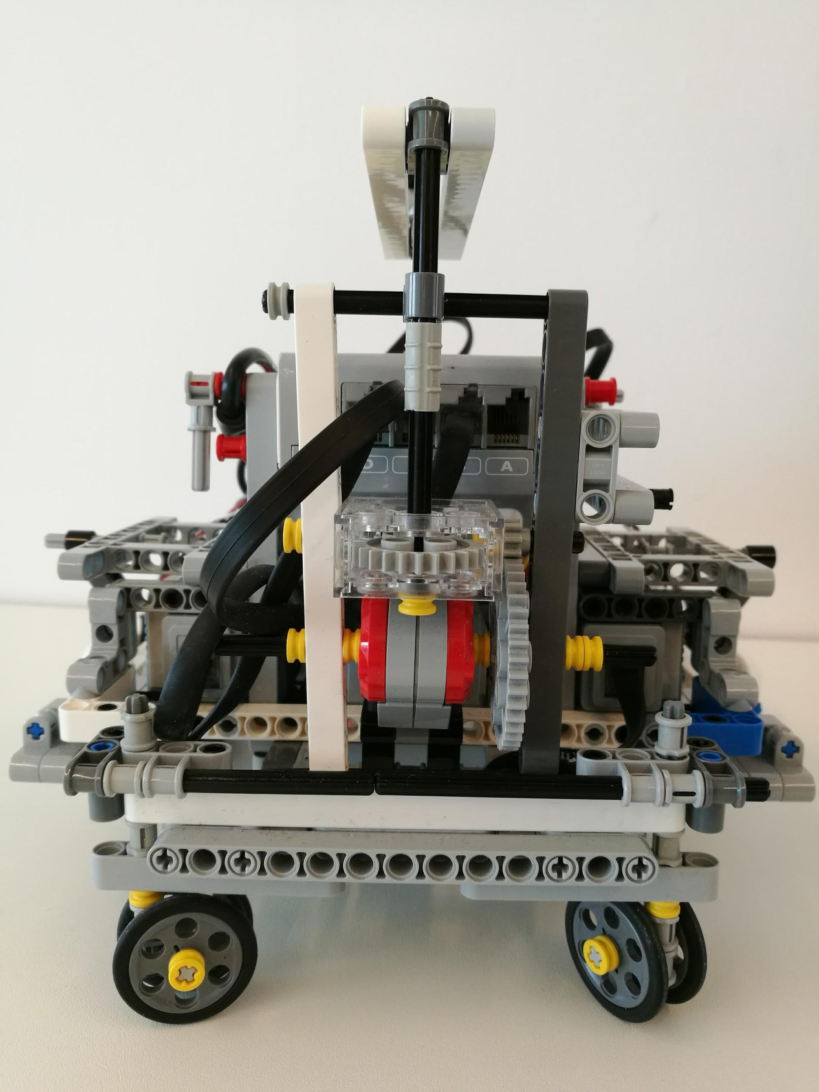GO colour sensors that help RoboTour locate its position in the world (it uses it to detect branches and delimiting lines). The custom line sensor is used to navigate along white lines on the floor.

The central element of the robot is the EV3 Brick that is the main computing node and also houses the battery pack. There is an arduino board that serves as a sensor hub in the front of the robot. See figure 6 for details on interconnection between the components.

## 3.3 Software and Hardware Structure

The robot and the Android app communicate with each other via a server which hosts a php file. Both the app and robot are able to read the server and send a post request to the server to update it. The php file used for the server is available in the git repository and the php file can be accessed through this link. <http://proparoxytone-icing.000webhostapp.com/receiver.php>

The purpose of this is to allow for multiple users to communicate with the robot. Fig 6 shows the communication between the Android app and EV3 and the process each part does.

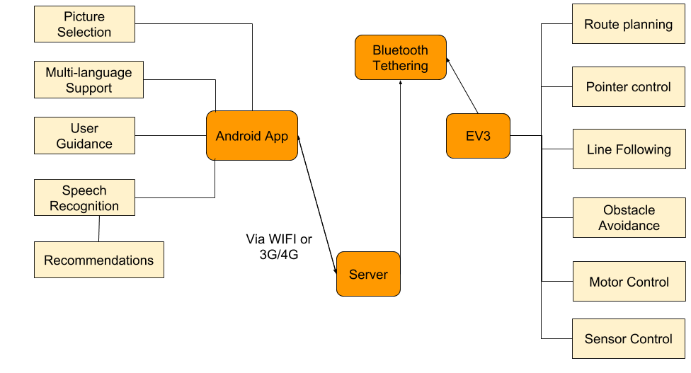

**Fig 6**: Communication structure between Android app and EV3

**Software Structure:**

**EV3:**

* main.py - main program
* sensor_hub.py - communication with the Sensor Hub and side sonars
* line_sensor.py - custom line sensor data processing
* dijkstra.py - path planning implementation
* comms.py - server communication

**Server**: receiver.php - receives and shows app and robot commands

(<http://proparoxytone-icing.000webhostapp.com/receiver.php>).

**APP:**

* RoboTour.apk

**Additional hardware firmware:**

* sensor_hub.ino - arduino project file for the sensor hub
* main.hex - compiled firmware for the line sensor
* main.c - firmware source code

# 4 Using Robotour

## 4.1 Physical Interaction

### 4.1.1 Turn on/off the brick

The brick can be turned on by long pressing button 4 in Fig 7. It takes approximately 40 seconds from the point of pressing the button for the EV3 to start up.

To turn off, press button 1 (Ev3dev.org, 2018a) in Fig 7 until Fig 8 appears on the screen,then press button 4 in Fig 7 and the EV3 will shutdown (Ev3dev.org, 2018b), this takes approximately 30 seconds to complete.

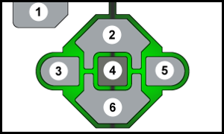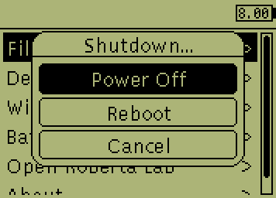

**Fig 7**: EV3 buttons (ev3dev 2018)  **Fig 8**: Exit menu triggered (ev3dev,2018)

### 4.1.2 Replacing and recharging batteries

To replace the battery first detach the EV3 Brick from the body of the robot. There are eight red safety pins holding the Brick in place. Pull them all one notch away from the brick. You should now be able to lift the brick from the chassis. Remove the sensor and motor connections if necessary. To release the battery, press on the two latches on the battery pack underneath the Brick.

Insert a new battery pack making sure that the two restrictors feed into their housings. Apply moderate pressure until you hear the latches snap in place.

The batteries last approximately 40 minutes from a full charge, and they take approximately 2 hours to charge from 0 to 100%.

The battery can be recharged with the supplied 10V/700ma barrel plug charger. Connect the charger to the power supply, locate the charging port in the battery underneath the brick (accessible from the back of the robot). Green LED will indicate good connection. Red LED will shine until the battery is fully charged.

￼

### 4.1.3 Connect motors and sensor

|  |  |  |  |
| --- | --- | --- | --- |
| **Element** | **Port** | **Element** | **Port** |
| Left drive motor | EV3 PORT B | Front ultrasonic sensor | EV2 PORT2 |
| Right drive motor | EV3 PORT D | Sensor hub | EV3 USB host port (Fig 10) |
| Pointer motor | EV3 PORT C | Left ultrasonic sensor | Sensor hub sensor port0 (Fig 9) |
| Left colour sensor | EV3 PORT 4 | Right ultrasonic sensor | Sensor hub sensor port1 (Fig 9) |
| Right colour sensor | EV3 PORT 1 | Front line sensor | Sensor hub I2C port (Fig 9) |

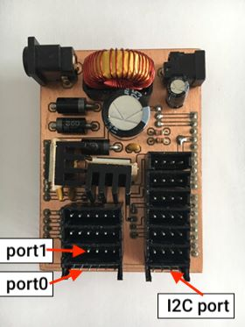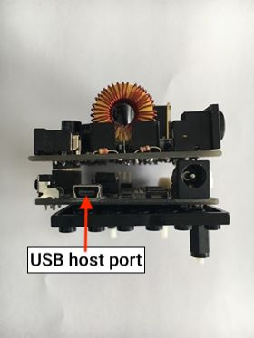

**Fig 9a**: Top of the board **Fig 9b**: Front of the board

### 4.1.4 Setup connection via bluetooth tethering

1. On the EV3, first verify that Bluetooth is powered on. In brickman, open the Wireless and Networks menu and select Bluetooth. Make sure the Powered checkbox is checked. Furthermore, make sure the Visible box is checked to make the EV3 discoverable.
2. Turn on Bluetooth on your Android device, then go to Tethering & Mobile Hotspot and turn on Bluetooth tethering, then go back to Settings and open Bluetooth and select your EV3 to pair it.
3. Confirm the passkey on both devices when requested.
4. On the EV3, find your Android in the list of Bluetooth devices and and select it.
5. Select Network Connection then select Connect.
6. State should change to Online. The Bluetooth icon will also indicate that you are connected and the IP address will be displayed at the top of the screen.

For further details how to connect with other devices, for bluetooth tethering, please visit see [Ev3dev.org (2018c)](http://www.ev3dev.org/docs/tutorials/connecting-to-the-internet-via-bluetooth/).

### 4.1.5 Starting position of the robot

Every time the robot is to be used, it should be placed at the starting point and point north as shown in Fig 11. Ensure the line lies between the two colour sensors.

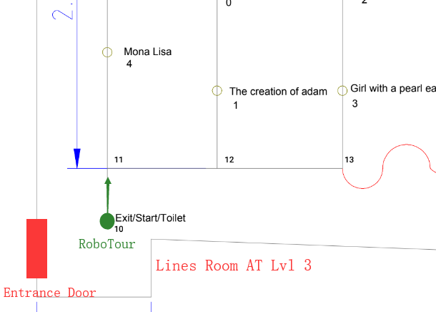

**Fig 11**: A map of the museum for the prototype in the lines room at 3.03 Appleton Tower.

## 4.2 Running the program from brick

To run the program from the brick, you can click on *File Browser -> main.py*. Once you hear “Please select the paintings you want to go”, then you can start running the app and proceed to making selections for the paintings you wish to visit.

## 4.3 Starting a tour with RoboTour

1. Turn on EV3 by pressing the middle button for approximately 3 seconds
2. After the system boots up establish internet connection over bluetooth (4.1.4)
3. Place the robot on the line in the starting position (4.1.5), ensuring that there is sufficient space around the robot for it to rotate freely - This is to allow for auto calibration
4. Launch the main program (see section 4.2)
5. RoboTour will now complete self-diagnosis and calibration by rotating left and right
6. RoboTour will indicate its readiness by a short sound message
7. Select Single or Double User mode (see section 4.4)
8. Turn on the companion app, press *Start* and select language
9. Select paintings that you are interested in using GUI and/or speech
10. Press *Start Tour*
11. The robot will now determine the optimal route and navigate you to the paintings that you chose, additionally providing you with short descriptions of the paintings
12. Further user interaction outlined in section 4.4

## 4.4 User Interaction

Functional capabilities and behaviours of the robot during single user, double user, and follower mode are outlined in this section. The robot must be in either Single or Double user mode in order to be operated. Follower mode is for users who would like to follow the tour when the robot is already in use.

Run the program as outlined in 4.2. Once the EV3 outputs a message about mode selection, press the “Left” EV3 button for Single User Mode and press the “Right” EV3 button for Double User Mode.

### 4.4.1 Single User Mode

Once the app is launched you can start using it after clicking the “Start” button. The next screen (Fig 12) will display languages for you to select, if your language is not shown, select the “?”. The description of the art pieces, audio description and all the settings will be in your selected language (provided that your language is supported).

In Fig 13, the user can select which art pieces he would like to see by tapping on the images. The user may also choose to search paintings or ask for recommendations via speech commands by tapping on the microphone or search bar.

The searches that work with the app are any sentence containing a own substring of:

* Art Piece name
* Artist name
* “Best”
* “Popular”
* “Recommend”
* “New”

(In their selected language).

After all are made selections, the user can press “Start Tour” and RoboTour will create an optimal route plan.

During tour mode (Fig 14), the robot will follow the white lines and allows a set of commands:

* **SKIP**: Skip the current painting
* **STOP/CONTINUE**: Pause the robot, or continue moving towards the painting
* **CANCEL**: Cancel the tour
* **CHANGE SPEED**: Adjust the speed of the robot
* **TOILET**: Navigate to the toilet
* **EXIT**: Navigate to the exit

In tour mode, selecting a picture from the carousel will bring up the description, the ETA, and the option to delete the painting. Selecting the text floating action button will bring up the ETA and description of the current painting. Pressing the speaker button will use text to speech to read out the description in the voice of your chosen language.

In Fig 15, after the tour has finished, the robot will go back to its starting position and the app will allow the user to either start again or close the app.

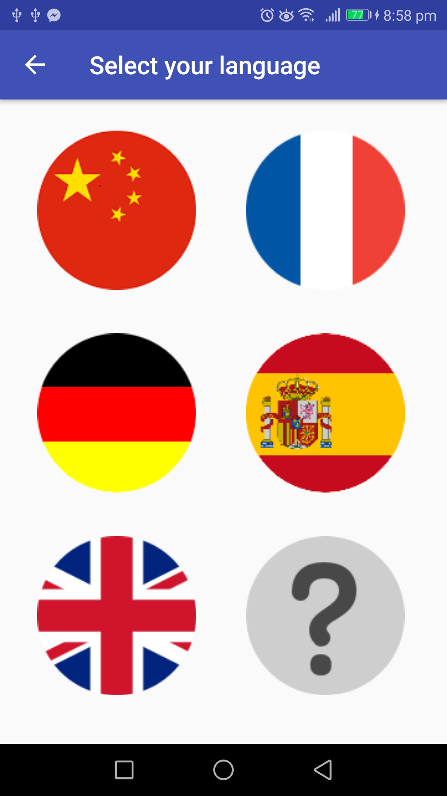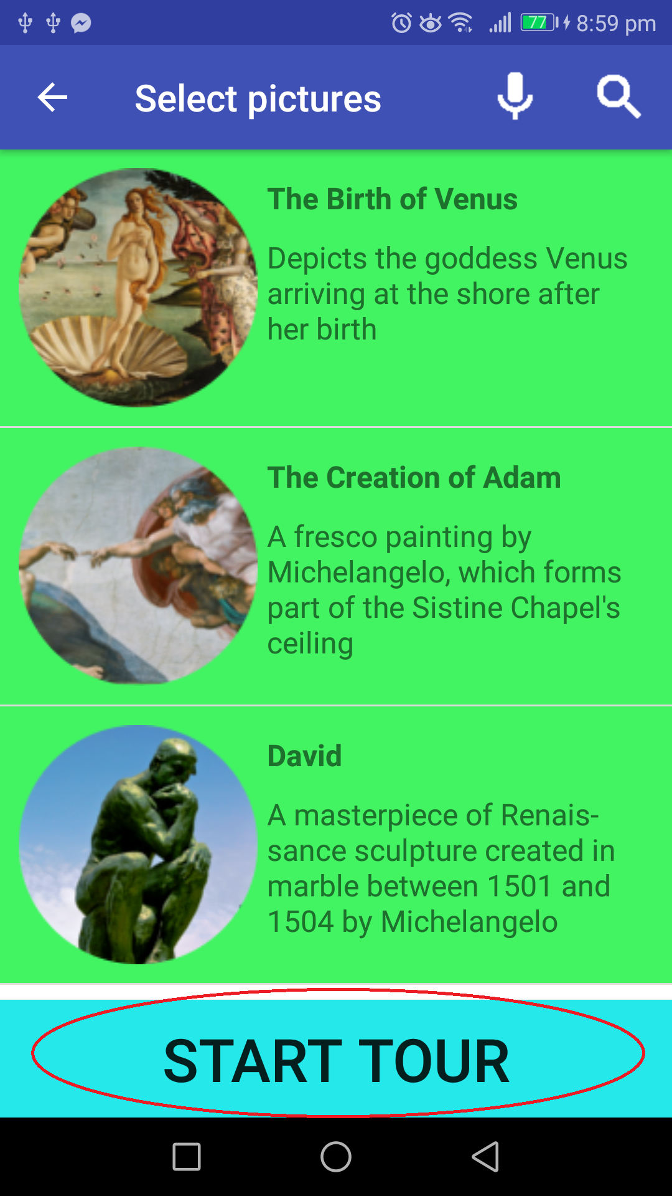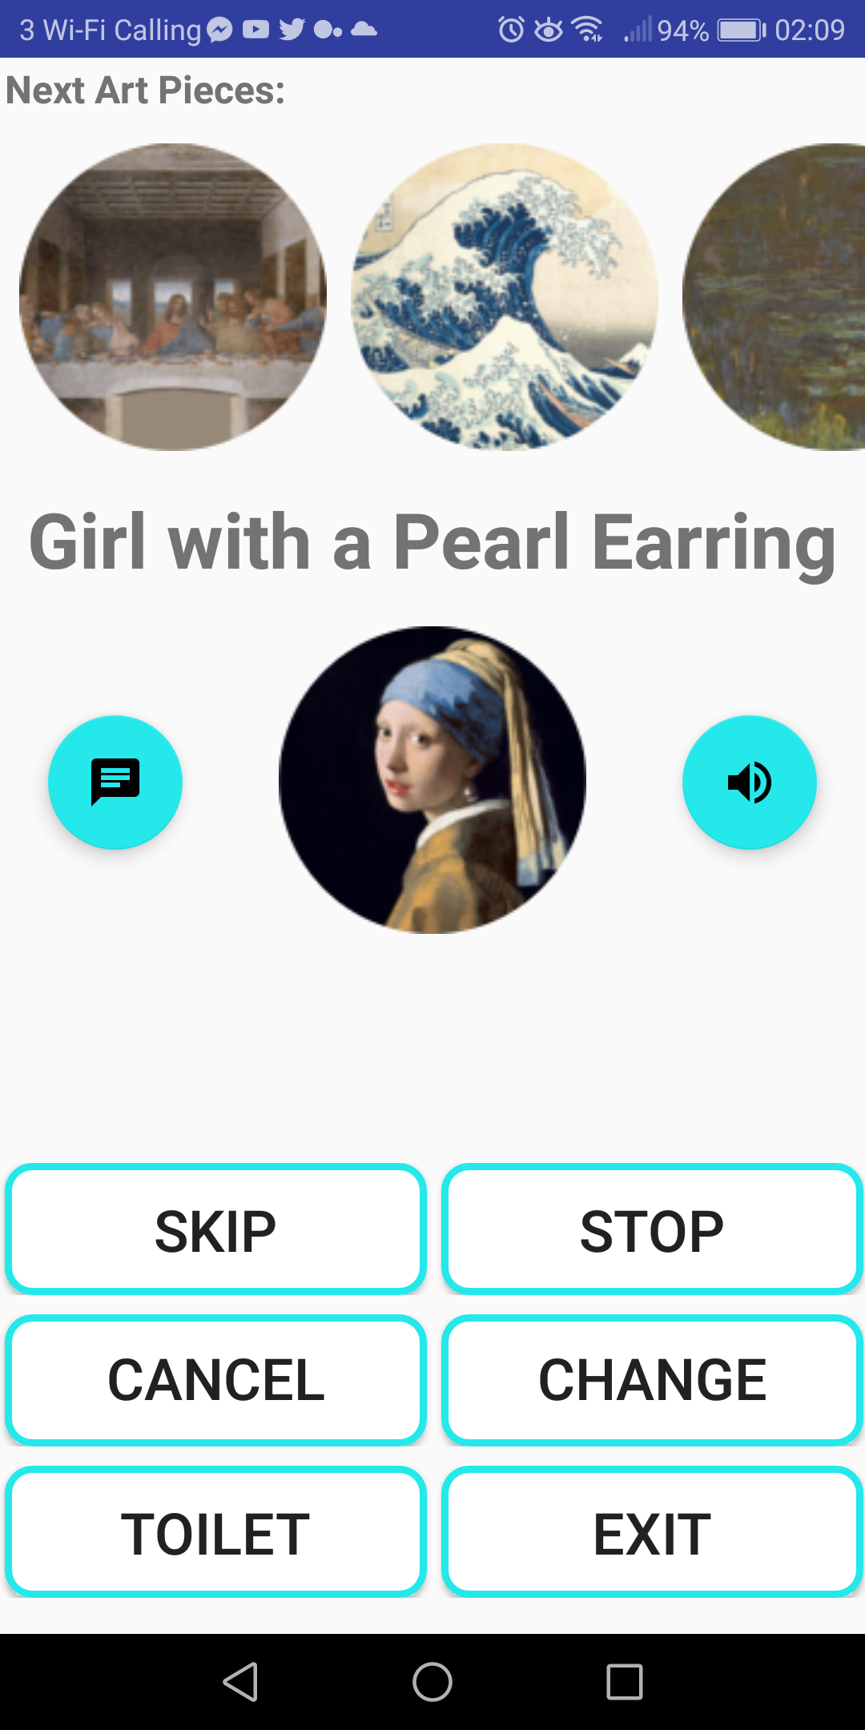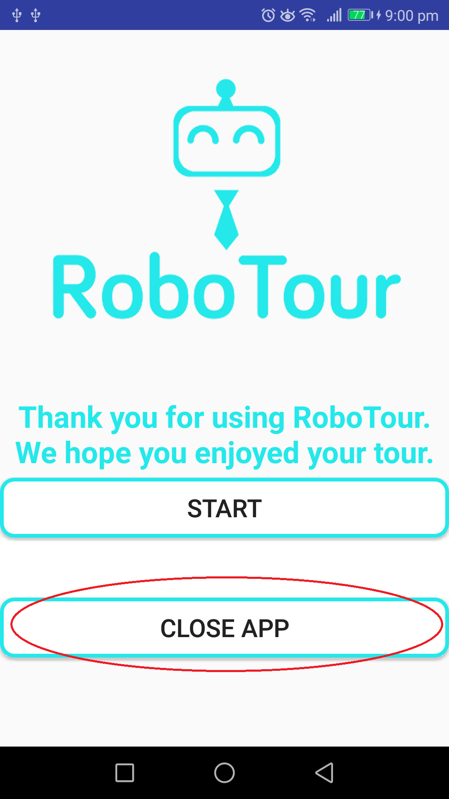

**Fig 12a**: Language selection **Fig 12b**: Painting Selection **Fig 12c**: Navigation **Fig 12d**: End

### 4.4.2 Dual user mode

In dual user mode, two users will be able to select the pictures they wish to go to (as in single user mode). RoboTour will navigate to all paintings that are selected by at least one user. Duplicate selections will be visited only once.

If a user wishes to delete or skip any painting, this will have to be mutually agreed upon between the users. A pop up will appear on the other users screen to determine this.

### 4.4.3 Follower Mode

In case RoboTour is already in use, or if the user(s) are in the process of making the selection of the paintings, you will be offered the option to follow the tour. The follower user can select languages different than the master users and listen to the audio description in their selected language. Follower mode has no control over the robot and works with both single user and double user.

### 4.4.4 Obstacle Avoidance

During the execution of the robot in any modes, when the robot is following a white line and detects an obstacle within the perimeter, the robot will just stop and not enter obstacle avoidance mode.

When the robot is following a white line on the outside perimeter and detects an obstacle, it will enter obstacle avoidance mode.The robot will first rotate 90 degrees in the direction towards the outward direction of the perimeter, and start using its corresponding ultrasonic sensor to keep a certain distance between the obstacle. The obstacle avoidance is completed once it returns to the white line.

# 

# 

# 5 Troubleshooting Guide

Below are listed some of most common problems that may occur during the robot setup and runtime:

|  |  |  |
| --- | --- | --- |
| **ID** | **Problem** | **Solution** |
| 1 | SSH from DICE to EV3 over USB fails: unknown host ev3dev | Using the interface on the EV3 Brick navigate to *Wireless and Network -> Wired -> IPv4 -> Custom*. Enter the following values: IP: 192.168.17.129  Subnet mask: 255.255.255.128 Gateway: 8 |
| 2 | Error message on terminal: could not connect to the central server | Check if bluetooth tethering between EV3 and Android device is setup properly, and make sure the device is connected to the internet. |
| 3 | Robot beeps three times and does not start moving after starting the program | Check if all sensors and motors are connected to appropriate ports. All disconnected devices will be shown on the terminal. Restart the program. If problem persists recharge the battery and try again. |
| 4 | Robot makes a series of short beeps or the front line sensor LED flashes. | Repeatedly press the reset button on the sensor hub and the reset button on the line sensor until the LED starts slowly fading on and off. |
| 5 | Robot fails to avoid an obstacle | Exit the program by pressing and holding the “Back” button on EV3. Hold it until the EV3 exits to the main menu. Move the robot to the starting position and restart the program. Ensure that the ultrasonic sensors are connected properly. |
| 6 | Robot does not follow the line properly | Make sure that the front line sensor is at approx. 4mm from the ground and parallel to it. Restart the program to allow recalibration of the sensor. During the calibration make sure that the entire sensor passes over both the line and the floor. |
| 7 | Robot stops at wrong markers | Make sure that the lego colour sensors are at approx 4mm from the ground. Restart the program. |
| 8 | Robot is turned on but not responsive to any commands | Force the EV3 to reset by removing the battery and placing it back in again. Turn on the EV3 brick. |
| 9 | Robot does not detect obstacles | Make sure that the obstacle meets necessary requirements 4.4.4 |

# 

# 6 References

Inf.ed.ac.uk. (2018). [online] Available at: http://www.inf.ed.ac.uk/teaching/courses/sdp/SDP2018/sdp_ev3.pdf [Accessed 17 Mar. 2018].

Ev3dev.org. (2018a). *Using the EV3 Buttons*. [online] Available at: http://www.ev3dev.org/docs/tutorials/using-ev3-buttons/ [Accessed 18 Mar. 2018].

Ev3dev.org. (2018b). *Getting Started with ev3dev*. [online] Available at: http://www.ev3dev.org/docs/getting-started/ [Accessed 18 Mar. 2018].

Ev3dev.org. (2018c). *Connecting to the Internet via Bluetooth*. [online] Available at: http://www.ev3dev.org/docs/tutorials/connecting-to-the-internet-via-bluetooth/ [Accessed 18 Mar. 2018].<http://www.ev3dev.org/docs/tutorials/connecting-to-the-internet-via-bluetooth/>